Google Workspace Log Collection
SIEM Integration Guide - Technical Implementation Document
Version 2.0

1. Executive Summary
This document provides comprehensive guidance on collecting logs from Google Workspace and exporting them to SIEM platforms (Google Chronicle/SecOps and Microsoft Sentinel). It covers licensing requirements, log types, authentication options, high-level architecture, and security best practices.

2. Google Workspace License Requirements
Understanding license requirements is critical for log collection. Different editions provide varying levels of access to audit logs and security features.

2.1 Edition Comparison
Edition | Max Users | Price/User/Mo | Storage | Audit Features
Business Starter | 300 | $7.20 | 30 GB | Basic
Business Standard | 300 | $14.40 | 2 TB | Enhanced
Business Plus | 300 | $21.60 | 5 TB | Full + Vault
Enterprise Standard | Unlimited | ~$27.60 | Flexible | Full + DLP
Enterprise Plus | Unlimited | ~$36 | Flexible | Full + Advanced
Cloud Identity Premium | Unlimited | $9 | N/A | Identity Only

2.2 Log Availability by License Type
Log Type | Starter | Standard | Plus | Enterprise | Cloud ID Prem
Admin Audit Logs | ✓ | ✓ | ✓ | ✓ | ✓
Login Audit Logs | ✓ | ✓ | ✓ | ✓ | ✓
OAuth Token Logs | ✓ | ✓ | ✓ | ✓ | ✓
SAML Audit Logs | ✓ | ✓ | ✓ | ✓ | ✓
Groups Audit Logs | ✓ | ✓ | ✓ | ✓ | ✓
Device Logs | ✓ | ✓ | ✓ | ✓ | ✓
Drive Audit Logs | ✗ | ✓ | ✓ | ✓ | ✗
Gmail Audit Logs | ✗ | ✓ | ✓ | ✓ | ✗
Calendar Logs | ✗ | ✓ | ✓ | ✓ | ✗
Meet Logs | ✗ | ✓ | ✓ | ✓ | ✗
Security Investigation Tool | ✗ | ✗ | ✗ | Plus only | Limited
BigQuery Export | ✗ | ✗ | ✗ | ✓ | ✗
Key Takeaways:
- Identity Security Only: Cloud Identity Premium provides login, SAML, OAuth, and device logs
- Full Workspace Monitoring: Business Standard or higher for Drive, Gmail, Calendar logs
- Advanced Analytics: Enterprise Plus for Security Investigation Tool
- Log Retention: Most logs retained 6 months; Gmail logs only 30 days

3. Google Chronicle/SecOps Analysis

3.1 Why Chronicle is Expensive
Google Security Operations (formerly Chronicle) is an enterprise-grade SIEM with several cost drivers:
- Infrastructure Scale: Built on Google's infrastructure with petabyte-scale processing and 12-month hot retention
- Threat Intelligence: Includes Mandiant and VirusTotal integration (premium services separately)
- AI/ML Capabilities: Gemini-powered detection authoring, natural language search, automated response
- SOAR Integration: Full orchestration, automation, and response with 300+ integrations
- Volume-Based Pricing: Costs scale with data ingestion volume

3.2 Pricing Overview
Metric | Value | Notes
Average Annual Cost | ~$315,000 | Based on market data
Maximum Observed | ~$880,000 | Large enterprise
Pricing Model | Per-employee or data volume | Contact sales for quote
ROI (IDC Study) | 407% over 3 years | ~7 month payback period

3.3 Chronicle Package Options
Package | SIEM Features | SOAR/Automation | Threat Intel
Standard | Core SIEM, 12mo retention | Basic playbooks | Standard feeds
Enterprise | Advanced analytics, UEBA | Full SOAR, 200+ rules | Mandiant basic
Enterprise Plus | 3500 rules, Gemini AI | AI playbooks, 300+ integrations | Full Mandiant + VirusTotal

3.4 Alternative SIEM Options
Platform | Cost Model | Pros | Cons
Microsoft Sentinel | Pay-per-GB ingested | Azure integration, flexible pricing | Costs scale with data volume
Splunk Enterprise | Per-GB or workload | Mature, extensive ecosystem | Can be expensive at scale
Elastic Security | Resource-based | Open source option available | Complex setup
Wazuh | Free / Support tiers | No license cost | Self-managed infrastructure

4. High-Level Architecture

4.1 Google Workspace to Microsoft Sentinel
The following architecture shows the data flow for exporting Google Workspace logs to Microsoft Sentinel:

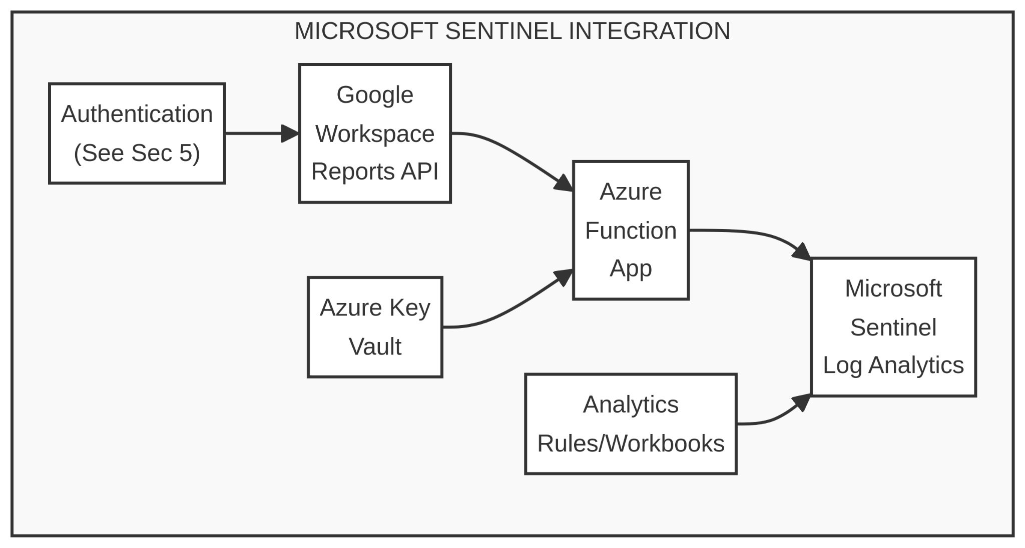

Components
- Google Workspace Reports API: Source of audit logs (Admin, Login, Drive, Gmail, etc.)
- Azure Function App: Serverless compute that polls API on schedule and forwards logs
- Azure Key Vault: Secure storage for credentials and secrets
- Microsoft Sentinel: SIEM platform for analysis, detection, and response

4.2 Google Workspace to Chronicle/SecOps
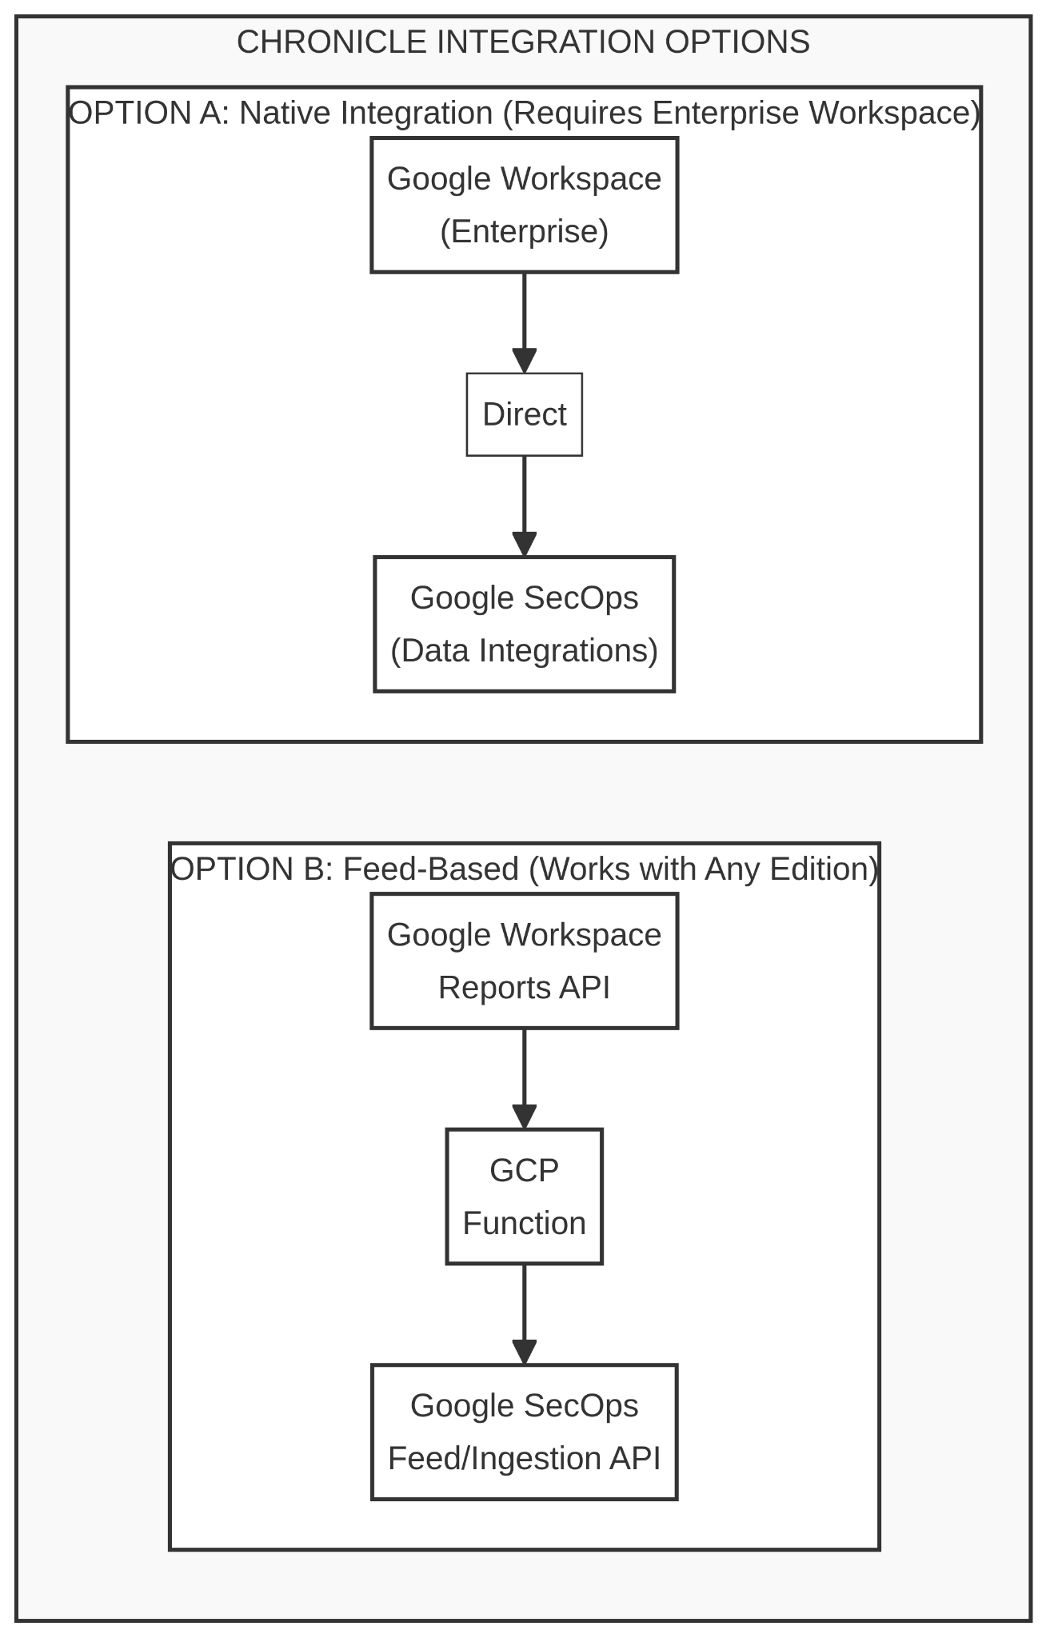

5. Authentication Options for Log Export
Multiple authentication methods are available for connecting Google Workspace to SIEM platforms. Each has different security characteristics.

5.1 Authentication Methods Comparison
Method | Credential Type | Security | Complexity | Key Lifetime
OAuth 2.0 (3-Legged) | Pickle/Refresh token | Low ⚠️ | Low | 6+ months
Service Account Key | JSON key file | Low ⚠️ | Low | No expiration
SA Key + Key Vault + Rotation | Rotated JSON key | Medium ✓ | Medium | 7 days (auto)
Workload Identity Federation | OIDC token exchange | High ✓✓ | High | 1 hour (auto)

5.2 Method Details

Option 1: OAuth 2.0 (3-Legged) - Simplest but Least Secure
- Admin authorizes application via browser
- Refresh token stored as pickle file
- Application exchanges refresh token for access tokens
Risks: Static credentials, tied to individual admin, manual rotation required

Option 2: Service Account with JSON Key
- Create service account in GCP
- Download JSON key file
- Configure domain-wide delegation in Workspace Admin
Risks: JSON key doesn't expire; compromise = full access until revoked

Option 3: Service Account + Key Vault + Auto-Rotation
Enhanced security through automated credential rotation:
- Store credentials in Azure Key Vault or GCP Secret Manager
- Enable Managed Identity for Function App
- Deploy automated key rotation function (weekly recommended)
- Rotation function creates new key, stores in vault, deletes old key

Option 4: Workload Identity Federation (RECOMMENDED)
Most secure approach - eliminates long-lived keys entirely.
How it works:
- Azure Function uses Managed Identity to get OIDC token
- Token exchanged with Google Security Token Service
- Short-lived Google credentials returned (1 hour)
- Credentials used to access Google Workspace APIs
Benefits: No long-lived secrets, automatic rotation, Azure AD authentication, reduced attack surface

5.3 Workload Identity Federation Architecture
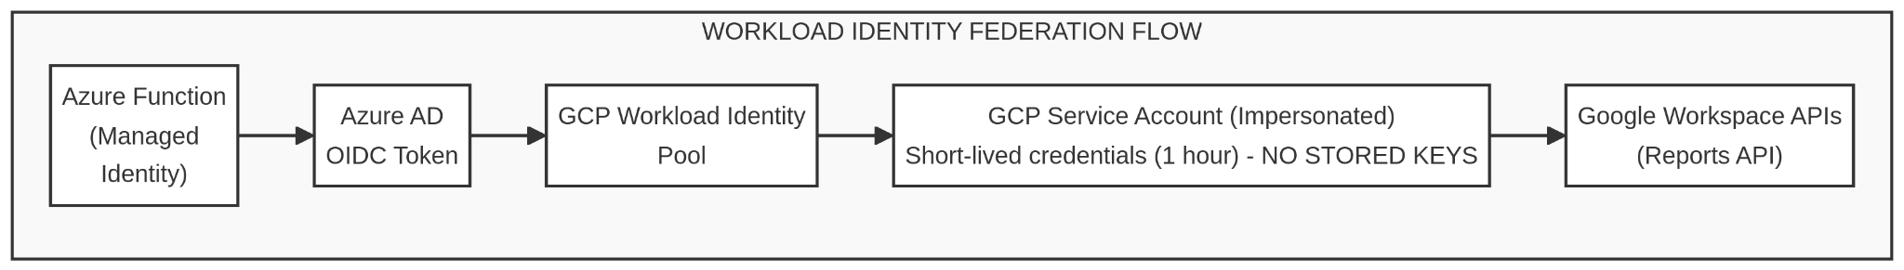

6. Implementation Roadmap

6.1 Phased Implementation Plan
Phase | Timeline | Tasks | Deliverables
Phase 1 | Week 1-2 | Set up Azure Key Vault, move credentials, enable Managed Identity | Secure credential storage
Phase 2 | Week 3-4 | Deploy key rotation function, configure timer trigger, set up monitoring | Automated rotation
Phase 3 | Week 5-8 | Configure Workload Identity Federation, update connector, remove keys | Zero-trust auth

6.2 Prerequisites Checklist
- Azure Subscription with Sentinel workspace
- Microsoft.Web/sites permissions for Azure Functions
- Google Workspace domain with API access enabled
- Google admin account with Reports API permissions
- GCP project (for Workload Identity Federation setup)

6.3 Log Tables Created in Sentinel
The Google Workspace connector creates these tables in Log Analytics:
- GWorkspace_ReportsAPI_admin_CL
- GWorkspace_ReportsAPI_calendar_CL
- GWorkspace_ReportsAPI_drive_CL
- GWorkspace_ReportsAPI_login_CL
- GWorkspace_ReportsAPI_mobile_CL
- GWorkspace_ReportsAPI_token_CL
- GWorkspace_ReportsAPI_user_accounts_CL

7. Cost Considerations
Component | Cost Model | Notes
Azure Functions | ~$0.10-0.30 per GB | Consumption-based
Log Analytics Ingestion | ~$2.76 per GB | Pay-as-you-go
Log Analytics Retention | 30 days free | Additional cost for longer
Azure Key Vault | ~$0.03 per 10K operations | Secrets storage

8. Important Notes
- Data Latency: 15-30 minutes typical; some logs may take hours
- Drive Logs: Require Business Standard or higher licenses
- Gmail Logs: Not available via Feed Management (requires native integration)
- Security Investigation Tool: Enterprise Plus only for full access
- Alternative: Microsoft Defender for Cloud Apps connector if M365 E5 license available
— End of Document —

